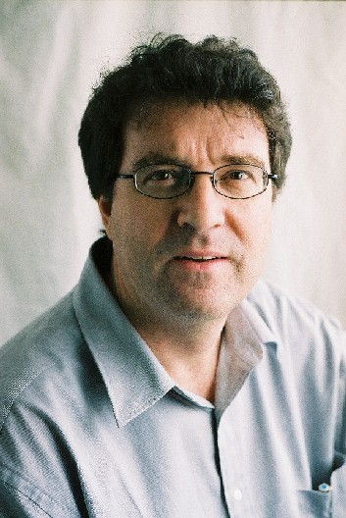
Colin Arrowsmith
BSurv, MSurvSc, MEnvS (Melb), GradDipEd (Hawthorn), PhD (RMIT), MSSI, FRGS.
Colin Arrowsmith is Associate Professor in Geographical Information Science in the School of Mathematical and Geospatial Sciences at RMIT University. Colin’s research interests include the application of spatial information science for resolving environmental problems, understanding the utilisation of nature-based tourist destinations, tourist spatial behaviour, and the use of information and communication technology in tertiary education. He currently teaches spatial information science, physical geography and quaternary environments and is the coursework postgraduate co-ordinator for geospatial science programs. He is an editor for the Journal of Spatial Science.

AN URBAN WATER CONSUMPTION MODEL FOR METROPOLITAN MELBOURNE
Jimmy Cheruseril and Colin Arrowsmith
School of Mathematical and Geospatial Sciences
RMIT University
GPO Box 2476V
Melbourne, Victoria 3001
Australia

Abstract
Water is a limited and an essential resource for living and its importance is understood by all. Being the driest of all the inhabited continents, Australia’s water resources are scarce at the best of times. Many of the river basins in Australia cover only a small area and the rivers that drain them are seasonal. Climate change coupled with increasing population and a growing economy has put stress on the existing water resources. Currently Australia is experiencing drought and the careful consumption of water is of high importance and there is a need to develop new methods to use water wisely. The state and Federal governments have initiated many campaigns over the past decade to reduce water consumption and conserve water. This paper discusses a study that set out to understand and estimate the socio-demographic relationship with water consumption using multivariate analysis techniques and geographic information systems (GIS).

The paper discusses a spatial approach based on multivariate analyses to investigate the spatial patterns of water consumption throughout the metropolitan area of Melbourne, Victoria, Australia. The approach was seen as an important assessment into the effectiveness of advertising and educational campaigns developed by the Victorian State Government to reduce residential water consumption. Multivariate techniques were used to develop a spatial model of water consumption based on socio-demographic predictors. Water consumption was seen to be closely correlated with separate dwellings and increased business counts. Thematic maps based on socio-demographic variables were used to visualise actual and predicted water consumption for metropolitan Melbourne.
Keywords: Water consumption; Multivariate analysis; Geographical information systems

1. Introduction
In her seminal poem “My Country” published in 1908, Dorothea Mackellar made mention of Australia as a land “…of drought and flooding rains…”. Eastern Australia comes under the influence of El Nino and as a result experiences periods of wet and dry extremes. Throughout 2006 and into 2007 eastern Australia is experiencing one of its most severe droughts in recorded history. Melbourne, like most of Australia’s large urban centres, is no exception when it comes to the need to effectively manage its water resources for urban use. Melbourne’s current water supplies are at approximately one third of capacity and at the time of writing this was decreasing with The Age newspaper reporting that at approximately 20% of capacity, Melbourne’s main reservoir is falling by about 1% per fortnight (The Sunday Age March 18 2007). With a rapidly increasing population (Melbourne has recorded the fastest rate of growth of any capital city in the first quarter of 2007) a mechanism for reducing water consumption through increased conservation is becoming increasingly important.
In an effort to understand water consumption behaviour in Melbourne, a postgraduate research project has been underway in an effort to determine how much influence socio-demographic factors, such as income, education and family backgrounds, as well as geographic factors including distance from the central business district, have on the water consumption patterns in Melbourne.
Melbourne consumes on an average 480,000ML of water a year from the Yarra, Thomson and Goulburn Basins (Melbourne Water, 2006_{a}). Water is distributed in metropolitan Melbourne by three major distributors namely City West Water in the western suburbs, Yarra Valley Water in the north eastern suburbs and South East Water in the south eastern suburbs. As a result of population growth there has been a corresponding increase in demand for water climate change. Coupled with the effects of global warming water reserves have declined significantly. Metropolitan Melbourne on a number of occasions has faced drought conditions and water resources have come under stress during these periods leading to water restrictions (Melbourne Water, 2001; 2003; 2006_{b}).

Water consumption in the urban environment tends to be dynamic and has been found to vary between low and high income people (Dube and Van der Zaag, 2003). Campbell et al 2004 found that water consumption was found to increase with property values due to the corresponding increase in the number of water fixtures. Troy and Holloway (2004) found that separate dwellings recorded higher rates of water consumption than medium density housing. Nancarrow and Porter (2004) evaluated lifestyle against water use and found that the main predictors for internal household water consumption are earnings, family size and various appliance ownership like spa baths, dishwashers and air conditioners.
Our research attempts to understand and estimate the socio-demographic relationship of water consumption in Greater Melbourne using multivariate analysis techniques. The water consumption for Metropolitan Melbourne during the period 2000-2005 has been examined at the “postcode” level. Postcodes are postal areas used in the delivery of postal documents. Various socio-demographic variables such as income, age group, qualification, home ownership, dwelling type and distance from Melbourne’s Central Business District (CBD) have been investigated in an effort to explain water consumption in Melbourne. Factor and regression analysis was used to develop a model based on socio-demographic predictors to estimate water use.

2. The study area
Melbourne is Australia’s second most populous city with a population of approximately 3.7 million people. Geographically it covers about 7500 square kilometres and has a relatively low density compared to other cities around the world.

Figure 1 shows water supply and demand estimates to 2055 for Melbourne. It shows the different possible scenarios with regard to water supply based on predicted severity of climate change. It also shows water demand based on the increasing population and economic growth.
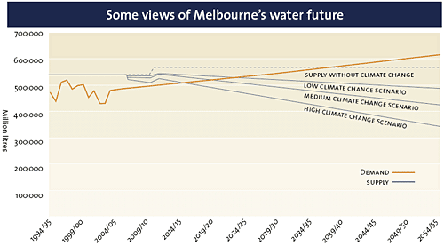
Source: Sustainable Water Strategy, Central Region Discussion Paper

Figure 1: Melbourne water supply and demand estimates. (Source: Melbourne Water, 2005)
From figure 1 it can be easily seen that water demand will outstrip water supply if current trends continue.

2.1. Socio-demographic Characteristics of Victoria
In Victoria some 70 percent of the population live in Melbourne. Almost one quarter of its residents were born overseas. The population growth rate in Victoria is 1.2 percent and the estimated population for the year 2051 is 6.5 million (ABS, 2006).
In Victoria 43.5 percent of households have three or more people living together. There are about 1.3 million families in Victoria, of which 1 million are couple families. Of the total couple families 45 percent are couples without children (ABS, 2006). In Victoria the gross household income per capita was AUD 28,000 in 2004-2005 (ABS, 2006). In Victoria there were 1.8 million occupied private dwellings in 2001 which is second only to NSW which had 2.5 million dwellings. In 2003-2004 approximately 80 percent of all Victorian dwellings were separate house dwellings, 9 percent were semidetached housing and 10 percent were flat or apartment dwellings. According to 2003-2004 estimates there were 2.6 persons per household in Victoria and dwellings had three bedrooms on an average (ABS, 2006).

3. Development of a digital database
Water consumption data was collected from the different water retail companies that distribute water in Greater Melbourne. The socio-demographic data used for this analysis came from Australian Bureau of Statistics 2001 census and business data. These datasets were combined together using a geographic information system to create a digital database.

3.1. Water Consumption Data
Three privately owned water authorities provide water to Melbourne. City West Water (CWW), South East Water (SEW) and Yarra Valley Water (YVW) provide the total billed water consumption see figure 2.
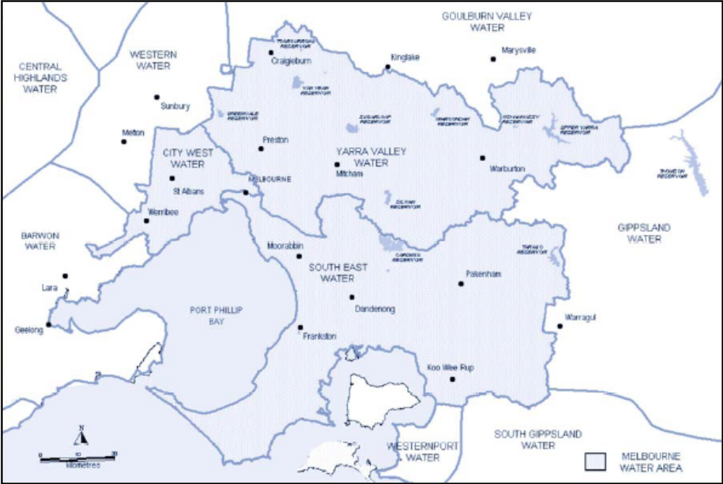

Figure 2: Retail water distributors in Metropolitan Melbourne (Source: Water Smart, 2006).
This data was acquired for 263 postcodes throughout Melbourne for nine years from 1996-97 through to 2004-05. Billed water is the water that has been paid for and excludes other transmission and operational water losses and therefore it reflects the actual amount of water used. The total billed water usage per postcode contained the total water used for all purposes including residential and commercial usage.
Attribute | CWW | SEW | YVW
Number of Postcodes | 42 | 102 | 119
Approx Area (Sqkm) | 1,130 | 3,640 | 4,000
Population (Million) | 0.70 | 1.30 | 1.60
Water Use 2004-05 (ML) | 95,495 | 139,276 | 144,845

Table 1: Attributes of water consumption data (Source: CWW, SEW & YVW, 2005)
The water consumption data received from the different water authorities were combined together at the postcode level to create a single database.

3.2. Socio-demographic Data
The socio-demographic data needed for the analysis was based on the ABS 2001 census and business data. ABS census data was sourced from the ABS website (ABS, 2001) and business data was obtained from a separately available CD. Socio-demographic data was extracted from the census data at the postcode level to enable socio-demographic data to be correlated with water consumption data. From the enormous ABS census data the Basic Community Profile (BCP) aggregated data set was chosen for this study. The BCP contains basic statistical information that gives an understanding of the demographic profile of an area. This data is split into 33 tables based on various socio-demographic factors. These tables provide information on age groups, martial status, birthplace, gender, family type, income groups, ethnicity, occupation, education levels, dwelling information, method of travel, computer use and other population characteristics.
Based on previous studies of factors that influence water consumption data from 22 tables were considered appropriate to be included in the analysis. From these 194 different types of socio-demographic attributes or variables were extracted. The attribute data from different tables were summarised to form common or general fields. The business data for the relevant postcodes was extracted from the Australian Bureau of Statistics Business Register. Geographic data such as distance from central Melbourne, the number of lots per postcode and postcode area were extracted using GIS. Postcodes were then assigned respective distance attributes. To calculate the number of lots or properties per postcode the property layer was joined based on spatial location with the postcode layer.

3.3. Database creation
The combined water consumption dataset, the selected socio-demographic variables and the attributes extracted from the spatial database were joined together. Figure 3 shows a flow chart of the various steps adopted to obtain the final analysis data. The joined data was exported and then imported into SPSS V13 for further analysis.
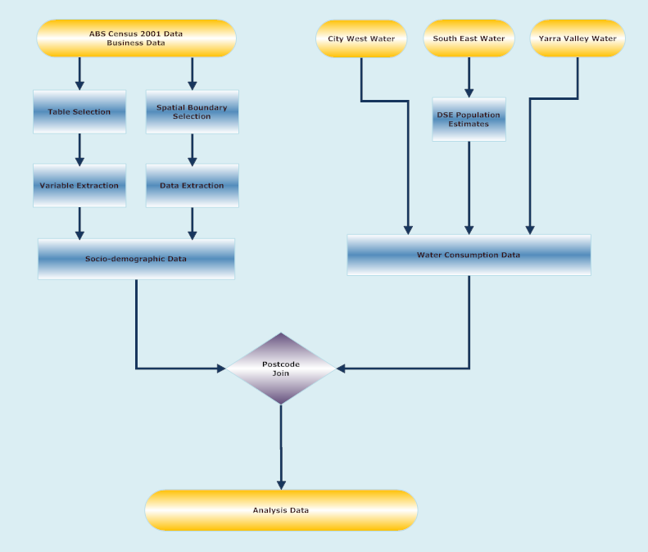

Figure 3: Flowchart describing the steps adopted to create the digital database.

4. Development of a water consumption model
Multivariate factor analysis and multiple regression were used to develop the water consumption model. Multivariate analysis is considered important for studies that rely heavily on many variables used to understand particular phenomena because it can examine multiple levels of a given problem. Multivariate analysis can be defined as a statistical method that analyses simultaneously multiple associations or measurements on each variable under investigation (Hair et al, 1995). Factor analysis is an exploratory statistical approach or multivariate technique which can be used to analyse and determine the interrelationships between large numbers of variables (Hair et al, 1995). Regression analysis is predictive approach. It a statistical method to predict the changes in the dependent variable based on several independent variables (Hair et al, 1995).
Water consumption data during the years 2000-2001 and 2004-2005 were used as dependent variables and the various socio-demographic data were used as independent variables in the multivariate analysis. The multivariate analysis was done in four steps. Initially the water consumption data and the various socio-demographic data were tested to meet the basic assumptions for factor and multiple regression analysis. In the second step, factor analysis was executed to determine or identify the interrelationships between the variables. Once the variables of significant influence were identified the analysis proceeded to the third step. In the third step regression analysis was used to quantify and predict the influence of the various independent socio-demographic variables on water consumption. Finally the regression equation or a model based on water consumption and socio-demographic variables was obtained. In the fourth step the regression model was tested for its validity. This methodology is explained using in the flow chart in figure 4. In this figure the entire methodology is described.

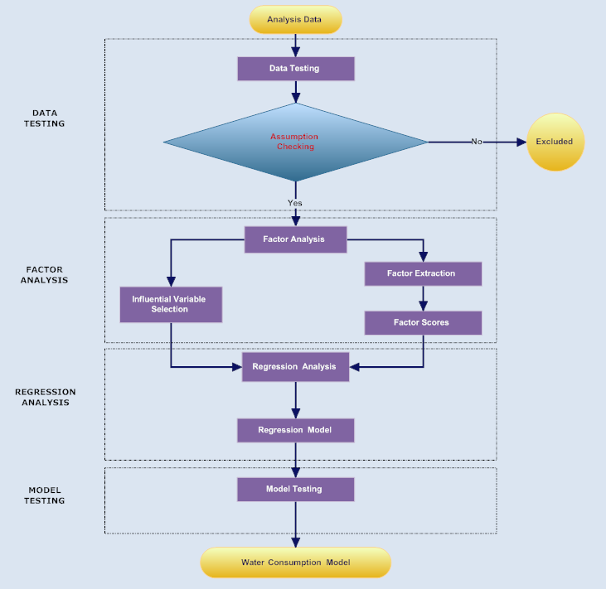

Figure 4: Flowchart shows the four different steps of analysis procedure.
The data testing procedure helped to identify the validity of the data by testing it for its accuracy, the presence of outliers and checked for the assumptions of normality, linearity and homogeneity. The factor analysis step helped to identify the variables of influence on water consumption and exclude the variables which did not have any significant impact. The various factors and factor scores gave an understanding of the influence of each of the socio-demographic variables and helped to classify them into groups based on their inter-relationships. The multivariate regression analysis was done with water consumption as a dependent variable and selected socio-demographic factors as independent variables, this helped to develop a model for water use. Eventually the model was tested; this helped to validate the model and improved its generalisation.

4.1. Variable Identification
Factor analysis was undertaken repeatedly using principle component analysis to arrive at a suitable result. A number of socio-demographic variables were removed from the analysis to obtain a correct result that met all the basic assumptions. The results of the final factor analysis are discussed here.
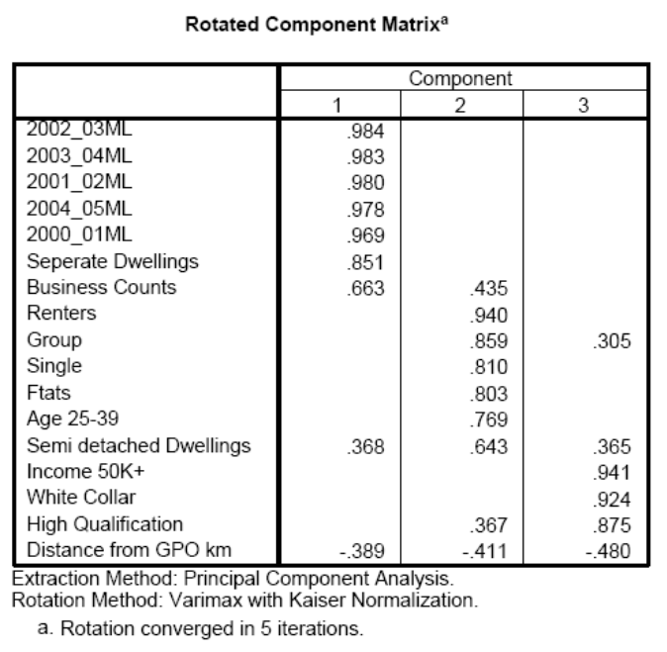

Table 2: Table shows the rotated component matrix or varimax rotation of the factor analysis output.
All the variables that have high loading on factor 1 relate to water consumption. Therefore factor 1 can be called water consumption and the variables included are water use for different years, separate dwellings, business counts, semi detached dwellings and the distance from the GPO. Separate and semi detached dwellings have loadings of .851 and .368 on factor 1 and business counts have a loading of .663: they have a positive relationship with water use. Distance from the General Post Office, generally regarded by Melburnians as the centre of Melbourne, has a negative loading of .389 on water use. It can be inferred from these variables that with an increase in the number of separate dwellings and business and a decrease in distance from the GPO water use increases.
Factor 2 presents a different picture with renters having the highest loading of .940. Group and single dwellers, flat and semi-detached dwelling counts, persons aged 25-39 and high qualification people have elevated loadings on factor 2. It indicates that Melbourne has young people in the age group 25-39 renting flats and living alone or in groups near the city with fairly good education. Factor 2 represents a young and outgoing population. Factor 2 bares no relation to water consumption.
Factor 3 has high loadings on a different set of variables. This factor consists of variables including income over fifty thousand per annum with a loading of .941, white collar professionals with a loading of .924, highly qualified people with a loading of .875, distance from the GPO has a negative loading of -.480 and group dwellers and semi-detached dwelling counts have loadings of .305 and .365 respectively. This shows that factor 3 represents qualified people and white collar workers with high income living near the city. Factor 3 represents an elite population and has no relation to water consumption.

4.2. Developing the linear equation
Based on the factor analysis results, the appropriate socio-demographic variables of influence were selected and extracted. The extracted socio-demographic variables or predictors were used in the regression analysis to quantify their relationship with water consumption. The different predictors included in the regression analysis should be chosen carefully as they have a great impact on the model. The variables or predictors selected for the regression analysis should be based on past research or statistical tests (Field, 2005). To start with, the entry method of regression was used for the analysis, where all the chosen variables were entered simultaneously into the model. Field (2005) suggested the use of entry method when the independent variables chosen are based on a sound theoretical basis, but also recommends the stepwise method of regression where the predictor variables are entered into the model individually depending on their mathematical significance. The analysis was done using both the stepwise and entry method of regression.
The linear equation obtained during the regression analysis can be seen in table 4.
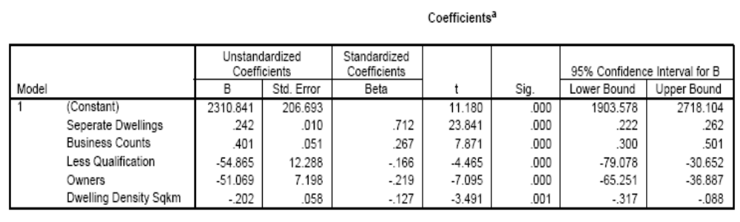

Table 4: Table shows the model coefficients of the regression analysis for 2004-05.
The general linear equation can be written as –
Water Consumption (2004-05) = 2310.84 + (0.242 SD) + (0.401 BC) - (54.87 LQ) - (51.07 OW) - (0.20 DD) ; – (2004-05)…………………………………………….. (1)
Water Consumption = 2313.09 + (0.267 SD) + (0.604 BC) - (73.67 LQ) - (41.28 OW) - (0.22 DD) ; – (2000-01) …………………………………………………….. (2)
Where,
SD – Separate dwellings
BC – Business counts
LQ – Less qualification
OW – Owner occupied dwellings
DD – Dwelling Density
This equation can be rewritten using the standardised beta coefficients of the water consumption model.
Water Consumption (2004-05) = 0.71SD + 0.27BC - 0.17LQ - 0.22OW - 0.13 DD ……………………………………………………….……………….. (3)
Water Consumption (2000-01) = 0.64SD + 0.33BC - 0.18LQ - 0.14OW - 0.11 DD ………………………………………………………………….…….. (4)
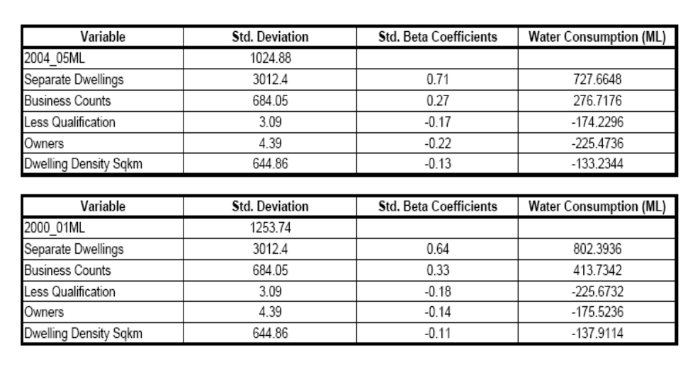

Table 5: Table shows the Beta coefficients and derived water consumption values.
The standardised beta coefficient is generated by SPSS. It represents the standard deviation of the predictor variable. By using the standardised beta coefficients of the model the exact effect of each variable on water consumption can be identified. In Table 5 standardised beta coefficients in equation 3 and 4 are multiplied by the standard deviations of the respective variables to derive water consumption in megalitres. From these equations the following inferences can be made:
- an increase in the number of separate dwellings, water consumption increases;
- when the number of businesses increases, water use also increases. Business counts are measured in numbers and water consumption in megalitres (ML);
- where the population is less academically qualified there is a corresponding decrease in water consumption;
- an increase in owner occupied dwellings results in a reduction in water consumption; and,
- where there is an increase in dwelling density, there is a corresponding decrease per head of population in water consumption.
Thus from the regression equation it can be said that the number of separate dwellings and businesses have a significant positive impact on water consumption. The number of less qualified people, owners and dwelling density also has an effect on water consumption but their impact is comparatively smaller and negative.

4.3. Evaluation of the water consumption model
The model was assessed by comparing the derived water consumption values obtained from the predictive variables in the model to the actual water consumption values provided by the three water companies. The actual values of the predictor variables are introduced into the regression equation and multiplied by the model coefficients to develop water use on a postcode level. This data set is then joined to the spatial dataset or the ABS census boundaries using the postcode field as a unique key. As a result a new spatial data set is created with relevant attributes. This derived dataset is thematically shaded and plotted on a map using a GIS.

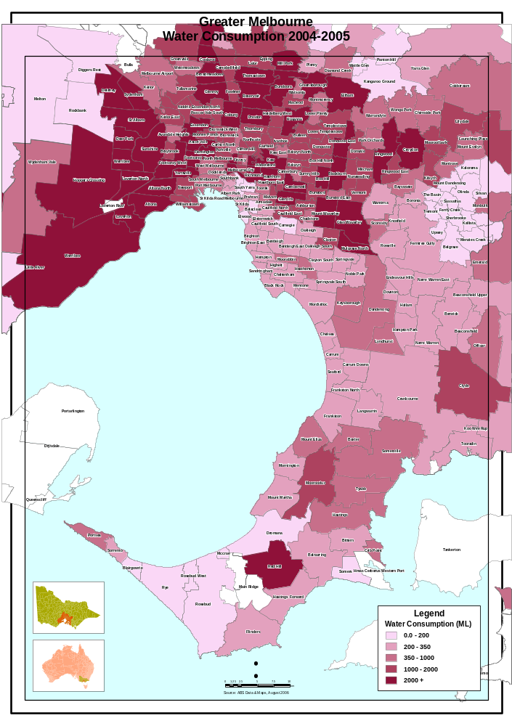
Figure 5: This map shows the water consumption for Greater Melbourne.

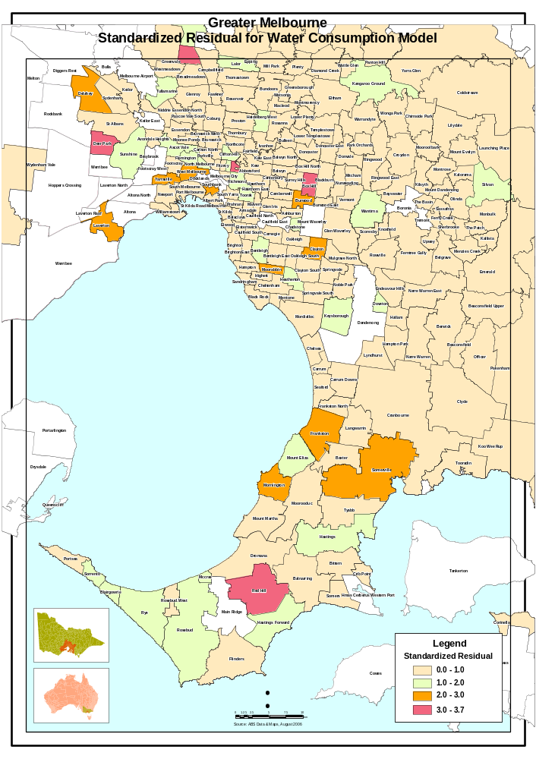 Figure 6: This map shows the standardised residual of the water consumption Model.

The standardised residual of the water consumption model is shown in figure 6. These represent the errors present in the model. The standardized residual was joined with the spatial dataset and thematically plotted on a map to visualise the model error across Greater Melbourne.
From the multivariate analysis and the map in figure 5 the influence of socio-demographic variables on water consumption can be determined. The map describes the error or residual in the model. It can be seen that the error is minimal in most areas throughout Greater Melbourne. However some postcodes exhibit large differences between predicted and actual. These locations are known to be either rapidly developing suburbs, or in predominantly agricultural areas on the urban fringe.
From the factor analysis socio demographic variables like separate dwellings, business counts, semi detached dwellings and the distance from the GPO were identified as having higher loading or influence on water consumption. However the variable, distance from the GPO, did not appear in the regression model as it did not have a significant amount of influence when compared to the other factors.
Initially a number of socio-demographic variables were introduced into the regression model but only the highly influential variables made their way into the model. Separate dwellings and business counts had the major positive influence on water consumption. Less qualified people, owner occupied homes and dwelling density had a negative effect on water consumption. The significance of these variables on water consumption is not high but noteworthy.

4.4 Limitations of the study
The data obtained was based on postcode district. Many postcodes are large areas and these areas tended to increase as the distance from the GPO increased. Some postcodes contain significant regions of parklands and reserves. Therefore for some cases the postcode may be too large and may not accurately represent the characteristics of a particular area. The model was derived based on a small sample size of 250 postcodes. For a similar study comprising of large number of variables a larger sample of at least 1000 cases is required to develop an accurate model (Field, 2005). During the model testing using the case summaries it was found that the resultant model had only 93 percent of the standardised residuals between ±2 and 97 percent are between ±2.5 standard deviations. For a good model 95 percent of the cases should have standardised residuals between ±2 and 99 percent between ±2.5 (Field, 2005). There were seven cases with standardised residual values above 2.5 and six of them above 3. These cases had very high residuals which marked a large deviation in the prediction of water consumption.

5. Conclusions
This paper has discussed the development of a water consumption model for metropolitan Melbourne. Whilst it has been developed for one city it is possible to transfer the modelling methodology to other major urban centres.
From the model developed for Melbourne water consumption seems to be directly related to the number of separate dwellings and businesses. It was found that water consumption increased with the increase in the number of separate dwellings and businesses. Educational background, owner occupied dwellings and dwelling density influences water consumption. There is still more work required to refine this model. Rainfall variability across Melbourne will influence the level of water used. This needs to be included in any further modelling.

Acknowledgements
Special thanks to Yarra Valley Water, City West Water and South-East Water for supplying the raw water consumption data for this study.

References
ABS (2001), Basic Community Profiles, Australian Bureau of Statistics, viewed 24/05/2006, <http://www8.abs.gov.au/ABSNavigation/prenav/LocationList?newgeography=Postal+Area+of+Usual+Residence&level1=2&areacode=&geography=Postal+Area+of+Usual+Residence&method=&productlabel=&producttype=Community+Profiles&navmapdisplayed=false&javascript=true&breadcrumb=PL&topholder=0&leftholder=0&currentaction=102&action=102&textversion=false&subaction=1>.
ABS (2006), Australian Social Trends 2006, 4102.0, Australian Bureau of Statistics, Canberra.
Campbell, HE, Johnson, RM and Larson, EH (2004), 'Prices, Devices, People, or Rules: The Relative Effectiveness of Policy Instruments in Water Conservation', Review of Policy Research, Volume 21, Number 5.
City West Water (2005), Sustainability Report 2005, City West Water Limited, Sunshine, Melbourne.
Dube, E and Zaag, P. (2003), 'Analysing water use patterns for demand management: the case of the city of Masvingo, Zimbabwe', Physics and Chemistry of the Earth, Parts A/B/C, vol. 28, no. 20-27, pp. 805-15.
Field, A 2005, Discovering Statistics Using SPSS, 2nd edn, SAGE.
Hair, JF, Anderson, RE, Tatham, RL & Black, WC (1995), Multivariate data analysis: with readings, Fourth edn, Englewood Cliffs, N.J.: Prentice Hall, Prentice Hall, New Jersey.
Melbourne Water 2001, 'A rich and fertile history', The Source, vol. 15, August 2001.
Melbourne Water 2003, 'The long road to recovery', The Source, vol. 25, May 2003.
Melbourne Water 2005, 'Leading the way at Albert Park', The Source, vol. 36, December 2005.
Melbourne Water 2006_{a}, Water Supply - Where Does Our Water Come From?, Melbourne Water, viewed 16/03/2006, <http://education.melbournewater.com.au/content/primary/water_supply.asp>.
Melbourne Water 2006_{b}, 'Journeys of discovery a century apart', The Source, vol. 38, June 2006.
Nancarrow, BE and Porter, NB 2004, Why Doesn’t it Work? The Incorporation of Community Culture in the Evaluation of Water Sensitive Urban Designs, CSIRO Land and Water.
South East Water 2005, South East Water Annual Report 2005, South East Water Limited, Heatherton, Melbourne.
The Sunday Age (2007). “Thompson Dam will be ‘bone dry in a year’”. Sunday March 18, 2007.
Troy, P & Holloway, D 2004, 'The Use of Residential Water Consumption as an Urban Planning Tool: A Pilot Study in Adelaide', Journal of Environmental Planning and Management, vol. 47, no. 1, p. 97–114.
Water Smart 2006, Draft Supply Demand Strategy for Melbourne 2006-2055, Water Smart, Melbourne.
Yarra Valley Water 2005, Sustainability and Annual Report 2004-05, Yarra Valley Water Limited, Mitcham, Melbourne.

